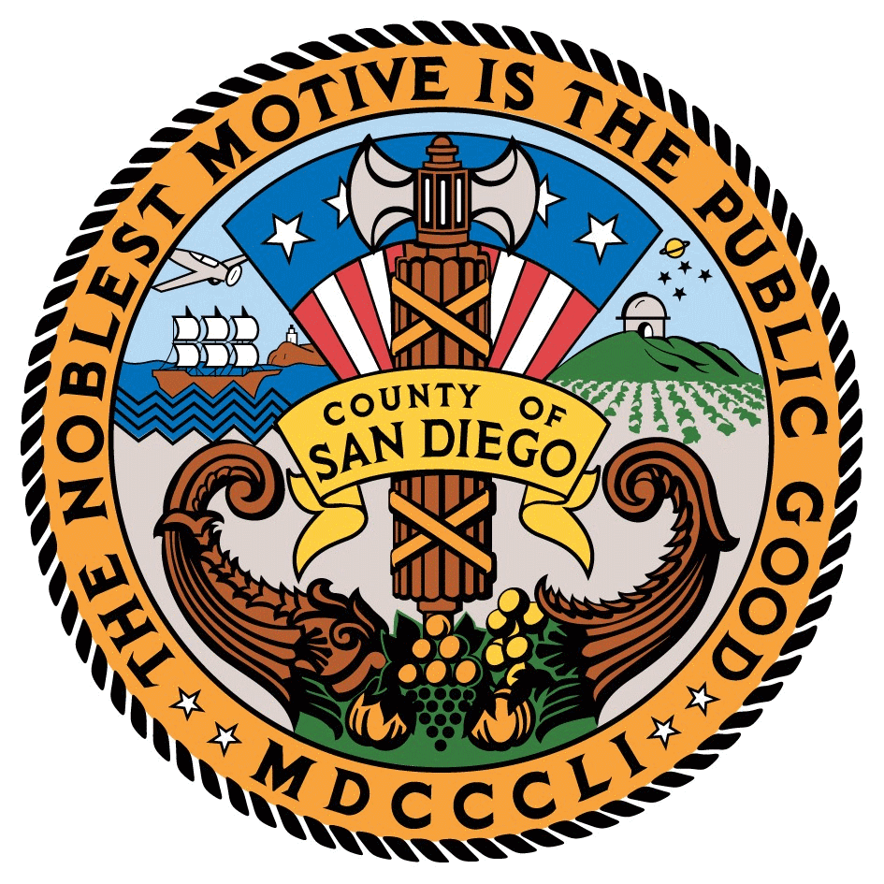
Positive Choice Integrative Wellness Center
County of San Diego Thrive Five Program Syllabus
Counselor: |  |  | Melanie Perkins, MS |  |  | Program Phone Number: |  |  | (858) 616-5600
Email: |  | Melanie.N.Perkins@kp.org |  |  |  | Counselor’s Voice Mail: |  | 858-519-1429
Day and Time: |  |  |  | Mondays at 5:30pm

Date | Topic
1/31/2021 | The New Thrive 5 and Putting Knowledge into Action
2/7/2021 | Energy Balance and Dining Out
2/14/2021 | The Plate Method: Proteins, Fats, Carbs
2/21/2021 | Gut health, Antioxidants, and Superfoods
2/28/2021 | Label Reading
3/7/2021 | Eating Mindfully and Maintaining Motivation
3/14/2021 | Stress and Building Resiliency
3/21/2021 | Grocery Shopping and Meal Prep

Each class also covers Meditation, Eating with Mindfulness, and Exercise.

Classroom Link:
https://forms.office.com/r/PjcPkVq1jF

